Literature & Fiction

I'll Be the One

[Lyla Lee](https://bookshop.org/contributors/lyla-lee) (Author)

[](https://images-production.bookshop.org/spree/images/attachments/12416512/original/9780062936929.jpg?1619646636)

Description

Diverse book recommended by The Today Show * A Kirkus Reviews Best Book of 2020

The world of K-Pop has never met a star like this. Debut author Lyla Lee delivers a deliciously fun, thoughtful rom-com celebrating confidence and body positivity--perfect for fans of Jenny Han and Julie Murphy.

Skye Shin has heard it all. Fat girls shouldn't dance. Wear bright colors. Shouldn't call attention to themselves. But Skye dreams of joining the glittering world of K-Pop, and to do that, she's about to break all the rules that society, the media, and even her own mother, have set for girls like her.

She'll challenge thousands of other performers in an internationally televised competition looking for the next K-pop star, and she'll do it better than anyone else.

When Skye nails her audition, she's immediately swept into a whirlwind of countless practices, shocking performances, and the drama that comes with reality TV. What she doesn't count on are the highly fat-phobic beauty standards of the Korean pop entertainment industry, her sudden media fame and scrutiny, or the sparks that soon fly with her fellow competitor, Henry Cho.

But Skye has her sights on becoming the world's first plus-sized K-pop star, and that means winning the competition--without losing herself.

### Product Details

Price

~~$17.99~~  **$16.55**

Publisher

Katherine Tegen Books

Publish Date

June 16, 2020

Pages

336

Dimensions

5.7 X 8.3 X 1.3 inches | 0.9 pounds

Language

English

Type

Hardcover

About the Author

Lyla Lee is the author of the Mindy Kim series as well as the upcoming YA novel, I'll Be the One. Although she was born in a small town in South Korea, she's since lived in various parts of the United States, including California, Florida, and Texas. Inspired by her English teacher, she started writing her own stories in fourth grade and finished her first novel at the age of fourteen. After working various jobs in Hollywood and studying psychology and cinematic arts at the University of Southern California, she now lives in Dallas, Texas. When she is not writing, she is teaching kids, petting cute dogs, and searching for the perfect bowl of shaved ice. You can visit her online at LylaLeeBooks.com.

The Last Story of Mina Lee (Original)

[Nancy Jooyoun Kim](https://bookshop.org/contributors/nancy-jooyoun-kim-6502912b-886c-48a0-b27a-ae6e73e4e9bf) (Author)

[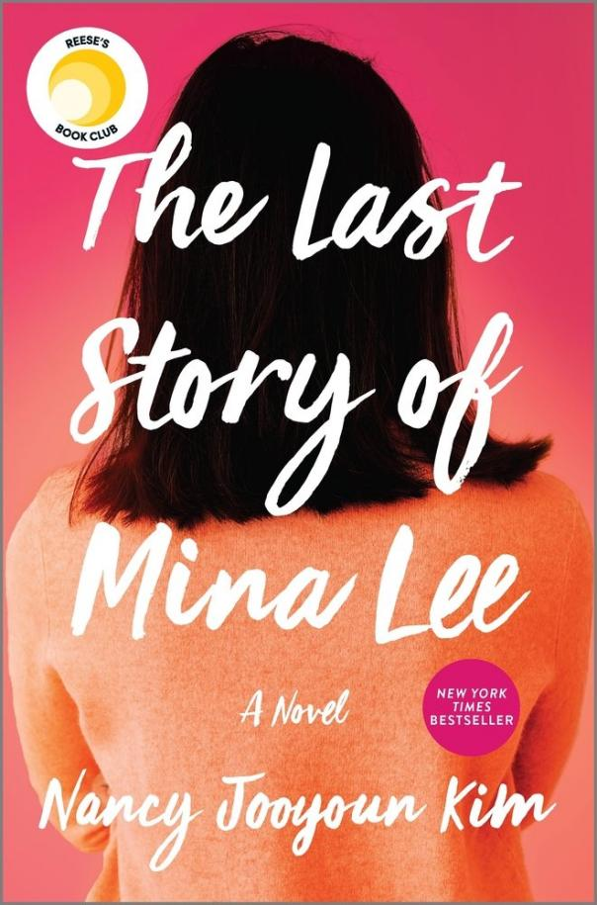](https://images-production.bookshop.org/spree/images/attachments/12084837/original/9780778310174.jpg?1619110755)

Description

A REESE'S BOOK CLUB PICK

INSTANT NEW YORK TIMES BESTSELLER

Riveting and unconventional, The Last Story of Mina Lee traces the far-reaching consequences of secrets in the lives of a Korean immigrant mother and her daughter

Margot Lee's mother is ignoring her calls. Margot can't understand why, until she makes a surprise trip home to Koreatown, LA, and finds that her mother has suspiciously died. Determined to discover the truth, Margot unravels her single mother's past as a Korean War orphan and an undocumented immigrant, only to realize how little she truly knew about her mother, Mina.

Thirty years earlier, Mina Lee steps off a plane to take a chance on a new life in America. Stacking shelves at a Korean grocery store, the last thing she expects is to fall in love. But that moment leads to repercussions for Mina that echo through the decades, leading up to the truth of what happened the night of her death.

Told through the intimate lens of a mother and daughter who have struggled all their lives to understand each other, The Last Story of Mina Lee is a powerful and exquisitely woven debut novel that explores identity, family, secrets, and what it truly means to belong.

HIGHLY ANTICIPATED BY FORTUNE - POPSUGAR - PUREWOW - BETCHES - GMA.COM - VULTURE - BUSTLE - THE MILLIONS - LITHUB - BOOKRIOT - BOOKISH

"Painful, joyous... A story that cries out to be told." --Los Angeles Times

"Kim is a brilliant new voice in American fiction." --Alexander Chee, author of How to Write an Autobiographical Novel

"Suspenseful and deeply felt." --Chloe Benjamin, author of The Immortalists

### Product Details

Price

~~$27.99~~  **$25.75**

Publisher

Park Row

Publish Date

September 01, 2020

Pages

384

Dimensions

6.3 X 9.1 X 1.4 inches | 1.15 pounds

Language

English

Type

Hardcover

About the Author

Born and raised in Los Angeles, Nancy Jooyoun Kim is a graduate of UCLA and the University of Washington, Seattle. Her essays and short fiction have appeared in the Los Angeles Review of Books, Guernica, NPR/PRI's Selected Shorts, The Rumpus, Electric Literature, Asian American Writers' Workshop's The Margins, The Offing, and elsewhere. The Last Story of Mina Lee is her first novel.

The Weight of Our Sky

[Hanna Alkaf](https://bookshop.org/contributors/hanna-alkaf) (Author)

[](https://images-production.bookshop.org/spree/images/attachments/10429184/original/9781534426085.jpg?1588350827)

Description

A music loving teen with OCD does everything she can to find her way back to her mother during the historic race riots in 1969 Kuala Lumpur, Malaysia, in this heart-pounding literary debut.

Melati Ahmad looks like your typical movie-going, Beatles-obsessed sixteen-year-old. Unlike most other sixteen-year-olds though, Mel also believes that she harbors a djinn inside her, one who threatens her with horrific images of her mother's death unless she adheres to an elaborate ritual of counting and tapping to keep him satisfied.

A trip to the movies after school turns into a nightmare when the city erupts into violent race riots between the Chinese and the Malay. When gangsters come into the theater and hold movie-goers hostage, Mel, a Malay, is saved by a Chinese woman, but has to leave her best friend behind to die.

On their journey through town, Mel sees for herself the devastation caused by the riots. In her village, a neighbor tells her that her mother, a nurse, was called in to help with the many bodies piling up at the hospital. Mel must survive on her own, with the help of a few kind strangers, until she finds her mother. But the djinn in her mind threatens her ability to cope.

### Product Details

Price

~~$18.99~~  **$17.47**

Publisher

Salaam Reads / Simon & Schuster Books for You

Publish Date

February 05, 2019

Pages

288

Dimensions

5.9 X 1.3 X 8.4 inches | 0.8 pounds

Language

English

Type

Hardcover

About the Author

Hanna Alkaf is the author of The Weight of Our Sky and The Girl and the Ghost. She graduated with a degree in journalism from Northwestern University and has spent most of her life working with words, both in fiction and nonfiction. She lives in Kuala Lumpur with her family.

Home

[Toni Morrison](https://bookshop.org/contributors/toni-morrison) (Author)

[](https://images-production.bookshop.org/spree/images/attachments/1800328/original/9780307740915.jpg?1588530167)

Description

This New York Times Notable Book is an emotional powerhouse of a novel about a modern Odysseus returning to a 1950s America mined with lethal pitfalls for an unwary Black man.

When Frank Money joined the army to escape his too-small world, he left behind his cherished and fragile little sister, Cee. After the war, he journeys to his native Georgia with a renewed sense of purpose in search of his sister, but it becomes clear that their troubles began well before their wartime separation. Together, they return to their rural hometown of Lotus, where buried secrets are unearthed and where Frank learns at last what it means to be a man, what it takes to heal, and--above all--what it means to come home.

A Washington Post Notable Work of Fiction  
A Best Book of the Year: NPR, AV Club, St. Louis Dispatch

### Product Details

Price

~~$14.95~~  **$13.75**

Publisher

Vintage

Publish Date

January 01, 2013

Pages

145

Dimensions

5.21 X 8.01 X 0.44 inches | 0.36 pounds

Language

English

Type

Paperback

About the Author

Toni Morrison is the author of eleven novels, from The Bluest Eye (1970) to God Help the Child (2015). She received the National Book Critics Circle Award, the Pulitzer Prize, and in 1993 she was awarded the Nobel Prize in Literature. She died in 2019.

Chlorine Sky

[Mahogany L. Browne](https://bookshop.org/contributors/mahogany-l-browne) (Author)

[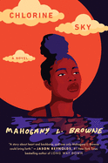](https://images-production.bookshop.org/spree/images/attachments/12931376/original/9780593176399.jpg?1595956544)

Description

A novel-in-verse about a young girl coming-of-age and stepping out of the shadow of her former best friend. Perfect for readers of Elizabeth Acevedo and Nikki Grimes.

Mahogany L. Browne's debut YA ia an absolute masterpiece. It will leave you breathless. -Elizabeth Acevedo, New York Times bestselling author of The Poet X

She looks me hard in my eyes  
& my knees lock into tree trunks  
My eyes don't dance like my heartbeat racing  
They stare straight back hot daggers.  
I remember things will never be the same.  
I remember things.

With gritty and heartbreaking honesty, Mahogany L. Browne delivers a novel-in-verse about broken promises, fast rumors, and when growing up means growing apart from your best friend.

### Product Details

Price

~~$17.99~~  **$16.55**

Publisher

Crown Books for Young Readers

Publish Date

January 12, 2021

Pages

192

Dimensions

5.6 X 8.3 X 0.9 inches | 0.66 pounds

Language

English

Type

Hardcover

About the Author

Mahogany L. Browne is a California-born, Brooklyn-based writer, educator, activist, mentor, and curator. She has published several books of poetry, and she is an Urban Word NYC Artistic Director (as seen on HBO's Brave New Voices), founder of Women Writers of Color Reading Room, and Director of BLM@Pratt Programming, and facilitates performance poetry and writing workshops throughout the country.  
  
Mahogany's poetry picture books include Black Girl Magic and Woke Baby.

Dreaming of You: A Novel in Verse

[Melissa Lozada-Oliva](https://bookshop.org/contributors/melissa-lozada-oliva) (Author)

[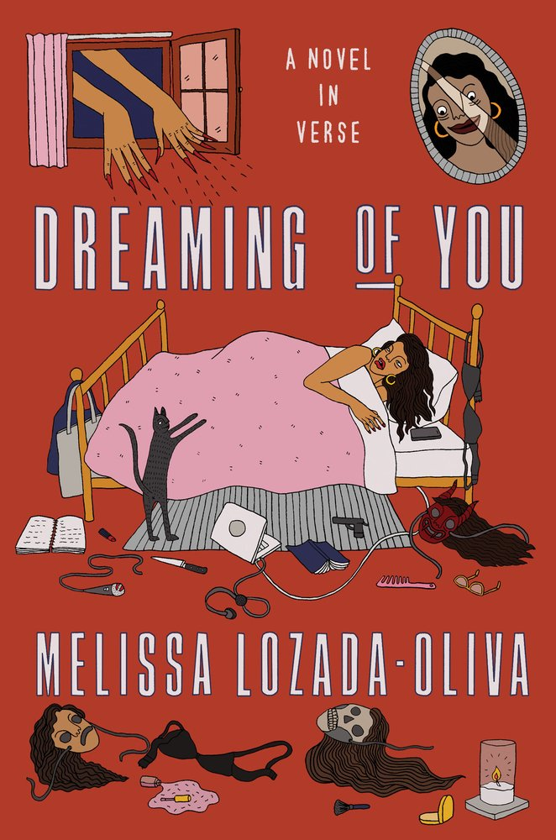](https://images-production.bookshop.org/spree/images/attachments/13948798/original/9781662600593.jpg?1618240887)

Description

A macabre novel in verse of loss, longing, and identity crises following a poet who resurrects pop star Selena from the dead.

Melissa Lozada-Oliva's Dreaming of You is an absurd yet heartfelt examination of celebrity worship.

A young Latinx poet grappling with loneliness and heartache decides one day to bring Tejano pop star Selena Quintanilla back to life. The séance kicks off an uncanny trip narrated by a Greek chorus of gossiping spirits as she journeys through a dead celebrity prom, encounters her shadow self, and performs karaoke in hell.

In visceral poems embodying millennial angst, paragraph-long conversations overheard at her local coffeeshop, and unhinged Twitter rants, Lozada-Oliva reveals an eerie, sometimes gruesome, yet moving love story.

Playfully morbid and profoundly candid, an interrogation of Latinidad, womanhood, obsession, and disillusionment, Dreaming of You grapples with the cost of being seen for your truest self.

### Product Details

Price

~~$23.00~~  **$21.16**

Publisher

Astra House

Publish Date

October 26, 2021

Pages

192

Language

English

Type

Hardcover

About the Author

Melissa Lozada-Oliva is the child of Guatemalan and Colombian immigrants. She co-hosts the podcast Say More and holds an MFA from NYU in poetry. Her writing has been featured in Remezcla, PAPER, The Guardian, The BreakBeat Poets Vol. 4, Wirecutter, Vulture, Bustle, Glamour, The Huffington Post, Muzzle Magazine, The Poetry Project, Audible, and BBC Mundo. She is from Massachusetts and lives in New York City.

Turtle Under Ice

[Juleah del Rosario](https://bookshop.org/contributors/juleah-del-rosario) (Author)

[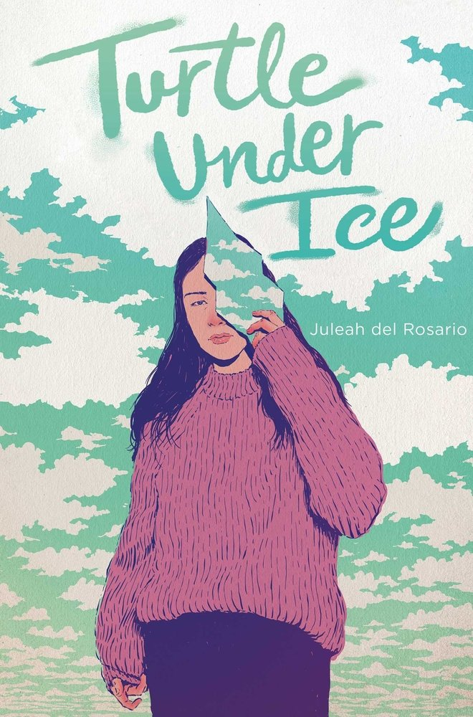](https://images-production.bookshop.org/spree/images/attachments/521145/original/9781534442955.jpg?1588401033)

Description

A teen navigates questions of grief, identity, and guilt in the wake of her sister's mysterious disappearance in this breathtaking novel-in-verse from the author of 500 Words or Less--perfect for fans of Elizabeth Acevedo.

Rowena feels like her family is a frayed string of lights that someone needs to fix with electrical tape. After her mother died a few years ago, she and her sister, Ariana, drifted into their own corners of the world, each figuring out in their own separate ways how to exist in a world in which their mother is no longer alive.

But then Ariana disappears under the cover of night in the middle of a snowstorm, leaving no trace or tracks. When Row wakes up to a world of snow and her sister's empty bedroom, she is left to piece together the mystery behind where Ariana went and why, realizing along the way that she might be part of the reason Ariana is gone.

Haunting and evocative--and told in dual perspectives--Turtle Under Ice examines two sisters frozen by grief as they search for a way to unthaw.

### Product Details

Price

~~$18.99~~  **$17.47**

Publisher

Simon & Schuster Books for Young Readers

Publish Date

February 11, 2020

Pages

272

Dimensions

5.8 X 8.3 X 1.0 inches | 0.8 pounds

Language

English

Type

Hardcover

About the Author

Juleah del Rosario is Chamorro and Filipina, and lives in Colorado where she works as a librarian. She is the author of 500 Words or Less and Turtle under Ice. Her favorite animal is and always has been a turtle.

Inside Out & Back Again

[Thanhhà Lai](https://bookshop.org/contributors/thanhha-lai-2201267a-60aa-48ad-82a0-79851c663494) (Author)

[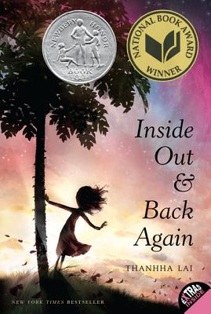](https://images-production.bookshop.org/spree/images/attachments/4146264/original/9780061962790.jpg?1589087299)

Description

Inside Out and Back Again is a #1 New York Times bestseller, a Newbery Honor Book, and a winner of the National Book Award!

Inspired by the author's childhood experience as a refugee--fleeing Vietnam after the Fall of Saigon and immigrating to Alabama--this coming-of-age debut novel told in verse has been celebrated for its touching child's-eye view of family and immigration.

Hà has only ever known Saigon: the thrills of its markets, the joy of its traditions, and the warmth of her friends close by. But now the Vietnam War has reached her home. Hà and her family are forced to flee as Saigon falls, and they board a ship headed toward hope--toward America.

This moving story of one girl's year of change, dreams, grief, and healing received four starred reviews, including one from Kirkus which proclaimed it enlightening, poignant, and unexpectedly funny.

An author's note explains how and why Thanhha Lai translated her personal experiences into Hà's story. This paperback edition also includes an interview with the author, an activity you can do with your family, tips on writing poetry, and discussion questions.

### Product Details

Price

~~$8.99~~  **$8.27**

Publisher

HarperCollins

Publish Date

January 02, 2013

Pages

288

Dimensions

5.1 X 7.5 X 0.7 inches | 0.4 pounds

Language

English

Type

Paperback

About the Author

Thanhhà Lai is the #1 New York Times bestselling author of Inside Out & Back Again, her debut novel in verse, which won both a National Book Award and a Newbery Honor, and the acclaimed Listen, Slowly and Butterfly Yellow, both of which were named to numerous best book of the year lists. She was born in Viêt Nam and now lives in New York with her family. To learn more about Thanhhà and her charity, Viet Kids Inc., visit www.thanhhalai.com.

When You Ask Me Where I'm Going

[Jasmin Kaur](https://bookshop.org/contributors/jasmin-kaur) (Author)

[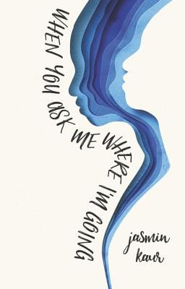](https://images-production.bookshop.org/spree/images/attachments/5979181/original/9780062912619.jpg?1588411026)

Description

Perfect for fans of Rupi Kaur and Elizabeth Acevedo, Jasmin Kaur's stunning debut novel is a collection of poetry, illustrations, and prose.

scream  
so that one day  
a hundred years from now  
another sister will not have to  
dry her tears wondering  
where in history  
she lost her voice

The six sections of the book explore what it means to be a young woman living in a world that doesn't always hear her and tell the story of Kiran as she flees a history of trauma and raises her daughter, Sahaara, while living undocumented in North America.

Delving into current cultural conversations including sexual assault, mental health, feminism, and immigration, this narrative of resilience, healing, empowerment, and love will galvanize readers to fight for what is right in their world.

### Product Details

Price

~~$18.99~~  **$17.47**

Publisher

HarperCollins

Publish Date

October 01, 2019

Pages

256

Dimensions

5.3 X 7.7 X 0.9 inches | 0.75 pounds

Language

English

Type

Hardcover

About the Author

Jasmin Kaur is a writer, illustrator, and spoken word artist living in Vancouver, BC. Her writing, which explores feminism, social empowerment, love, and survival, acts as a means of healing and reclaiming identity. As an arts facilitator and fourth-grade teacher, Jasmin has been leading creative writing workshops for young people across North America, the UK, and Australia over the past fi ve years. Visit her online at [www.jasminkaur.com.](http://www.jasminkaur.com.)

The Twelve Tribes of Hattie

[Ayana Mathis](https://bookshop.org/contributors/ayana-mathis) (Author)

[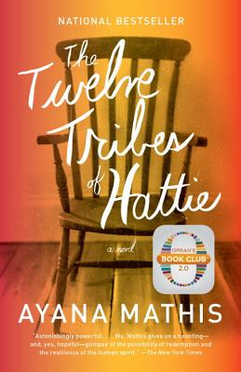](https://images-production.bookshop.org/spree/images/attachments/7302621/original/9780307949707.jpg?1588544232)

Description

"A remarkable page-turner of a novel." --Chicago Tribune  
  
In 1923, fifteen-year-old Hattie Shepherd, swept up by the tides of the Great Migration, flees Georgia and heads north. Full of hope, she settles in Philadelphia to build a better life. Instead she marries a man who will bring her nothing but disappointment, and watches helplessly as her firstborn twins are lost to an illness that a few pennies could have prevented. Hattie gives birth to nine more children, whom she raises with grit, mettle, and not an ounce of the tenderness they crave. She vows to prepare them to meet a world that will not be kind. Their lives, captured here in twelve luminous threads, tell the story of a mother's monumental courage--and a nation's tumultuous journey.

A New York Times Notable Book  
An NPR Best Book of the Year  
A Buzzfeed Best Book of the Year  
An Oprah's Book Club 2.0 selection

### Product Details

Price

~~$16.95~~  **$15.59**

Publisher

Vintage

Publish Date

October 08, 2013

Pages

320

Dimensions

5.24 X 0.68 X 7.96 inches | 0.51 pounds

Language

English

Type

Paperback

About the Author

Ayana Mathis is a graduate of the Iowa Writers' Workshop and is a recipient of the Michener-Copernicus Fellowship. The Twelve Tribes of Hattie is her first novel. Originally from Philadelphia, she lives in Brooklyn.